Report On

SignSense: Deep CNN-Based Traffic Sign Recognition

Submitted in partial fulfillment of the requirements of the Course Project for Deep Learning in Semester VII of Final Year Artificial Intelligence & Data Science

By

Yash Rane (Roll No. 39)
Dishant Sasane (Roll No. 42)
Shayaan Shaikh (Roll No. 45)

Under the guidance
of
Mr. Manas Tambe

University of Mumbai

Vidyavardhini's College of Engineering & Technology

Department of Artificial Intelligence & Data Science


(A.Y. 2026-27)
CERTIFICATE

This is to certify that the project entitled “SignSense: Deep CNN-Based Traffic Sign Recognition” is a bonafide work of Shayaan Shaikh (Roll No. 45), Yash Rane (Roll No. 39), Dishant Sasane (Roll No. 42) submitted to the University of Mumbai in partial fulfillment of the requirement of the Course Project for Deep Learning in Semester VII of Final Year Artificial Intelligence & Data Science.

_____________________
Guide

Abstract
Traffic sign recognition is a key part of driver assistance systems and self-driving cars. This project, SignSense, classifies images of road traffic signs into 43 classes using deep learning on the German Traffic Sign Recognition Benchmark (GTSRB), which contains 39,209 training and 12,630 test images. We designed a compact convolutional neural network (CNN) trained from scratch on 32x32 images with data augmentation, dropout and batch normalization, and compared it with transfer learning using MobileNetV2 pre-trained on ImageNet. The custom CNN with batch normalization achieved 98.60% accuracy on the official test set using only 487,243 parameters. MobileNetV2 reached 88.30% after fine-tuning its top 60 layers, and only 66.75% with light fine-tuning. Error analysis shows that most mistakes involve triangular warning signs with small, similar symbols and rare classes. A Streamlit web application shows the model's prediction, confidence and top-3 predictions for unseen test images.

Table of Contents
Chapter No. |  |  | Title | Page Number
1 |  |  | Introduction | 1
 | 1.1 |  | Motivation | 1
 | 1.2 |  | Background | 1
2 |  |  | Problem Statement | 1
 | 2.1 |  | Objectives | 1
 | 2.2 |  | Dataset | 2
3 |  |  | Proposed System | 3
 | 3.1 |  | Block diagram, its description and working | 3
 | 3.2 |  | Module Description | 4
4 |  |  | Implementation Result and Analysis | 4
 | 4.1 |  | Implementation Screenshots | 5
 | 4.2 |  | Training and Test Results | 5
 | 4.3 |  | Comparison of Model A and Model B | 6
 | 4.4 |  | Error Analysis | 7
5 |  |  | Code | 8
6 |  |  | Conclusion | 10
 | 6.1 |  | Limitations and Future Scope | 11
 |  |  | References | 11

1. Introduction

1.1 Motivation
Road traffic signs inform drivers about speed limits, dangers, priorities and mandatory directions. Missing or misreading a sign can cause accidents, especially at night, in bad weather or when the driver is tired. Advanced Driver Assistance Systems (ADAS) and self-driving cars therefore need to recognise traffic signs automatically, quickly and reliably.
The task is harder than it looks. Real photos vary in lighting, blur, viewing angle and distance, and many signs look alike: speed limits differ by a single digit, and many warning signs share the same red triangle and differ only in a small black symbol in the middle.

1.2 Background
Convolutional Neural Networks (CNNs) learn visual features such as edges, shapes and symbols directly from data, and have become the standard approach for image classification. The GTSRB benchmark [1] showed that machine learning methods can match human performance on traffic sign recognition. Transfer learning reuses a network pre-trained on a large dataset such as ImageNet; MobileNetV2 [2] is a lightweight network designed for mobile devices. Our models also use batch normalization [3], dropout [4] and the Adam optimizer [5].
This project builds a small CNN from scratch, compares it with MobileNetV2 transfer learning, analyses the errors, and provides a web demo that predicts the sign in unseen test images.

2. Problem Statement
Build a deep learning system that takes an image of a road traffic sign and correctly classifies it into one of 43 classes (stop, yield, speed limits, turn signs, etc.), with high accuracy, proper evaluation and an easy-to-use demo.

2.1 Objectives
- Build and train a custom CNN from scratch that reaches at least 95% test accuracy.
- Build a second model using transfer learning (MobileNetV2) and compare it with the custom CNN.
- Evaluate both models with accuracy and loss curves, a confusion matrix, per-class precision, recall and F1-score, and analysis of wrong predictions.
- Build a web demo that shows the predicted sign and its confidence for test images.
- Produce clean, documented and reproducible code.

2.2 Dataset
We use the German Traffic Sign Recognition Benchmark (GTSRB) [1] from Kaggle [6]. It contains real photos taken from a moving car, cropped around the sign.
- Classes: 43 sign types (speed limits, prohibitions, warnings, mandatory directions).
- Size: 39,209 training images and 12,630 test images; image sides range from 25 to 266 pixels, and many are dark or blurry.
- Class imbalance: from 210 images (Speed limit 20 km/h) to 2,250 images (Speed limit 50 km/h) per class, with a mean of 912 (Fig. 2.1).
- Split: 80% training (31,367 images) and 20% validation (7,842 images), stratified by class. The official test set is used only for the final evaluation.
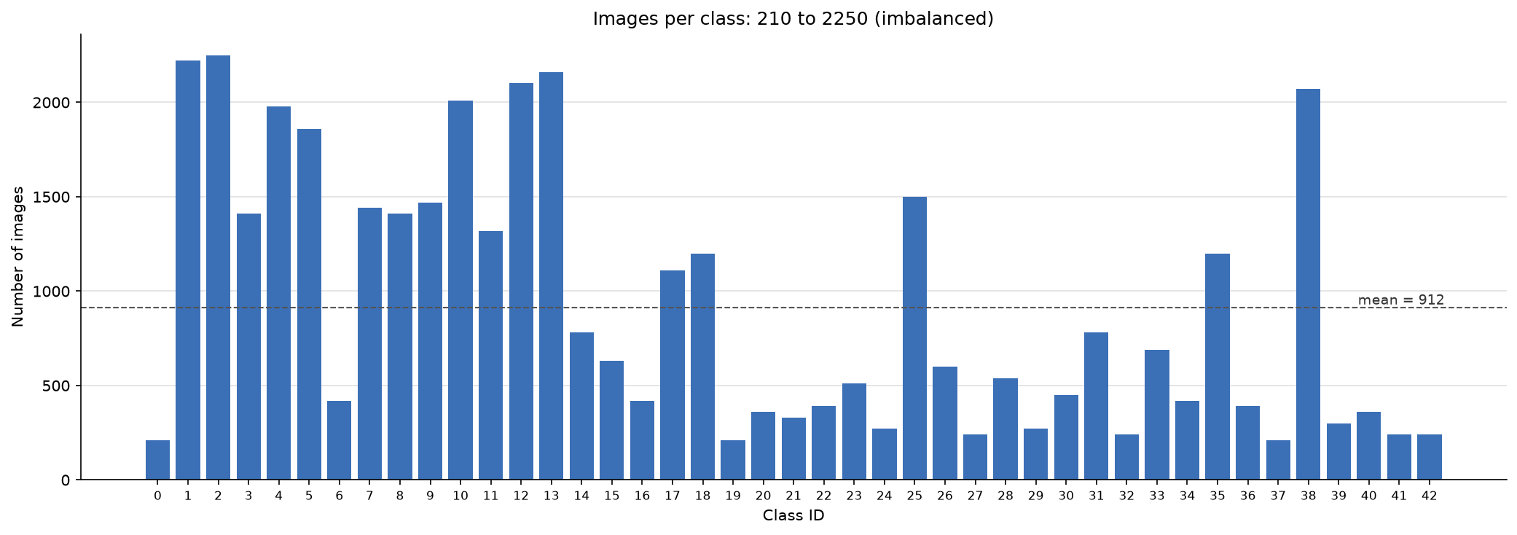
Fig. 2.1: Number of training images per class

3. Proposed System

3.1 Block diagram, its description and working
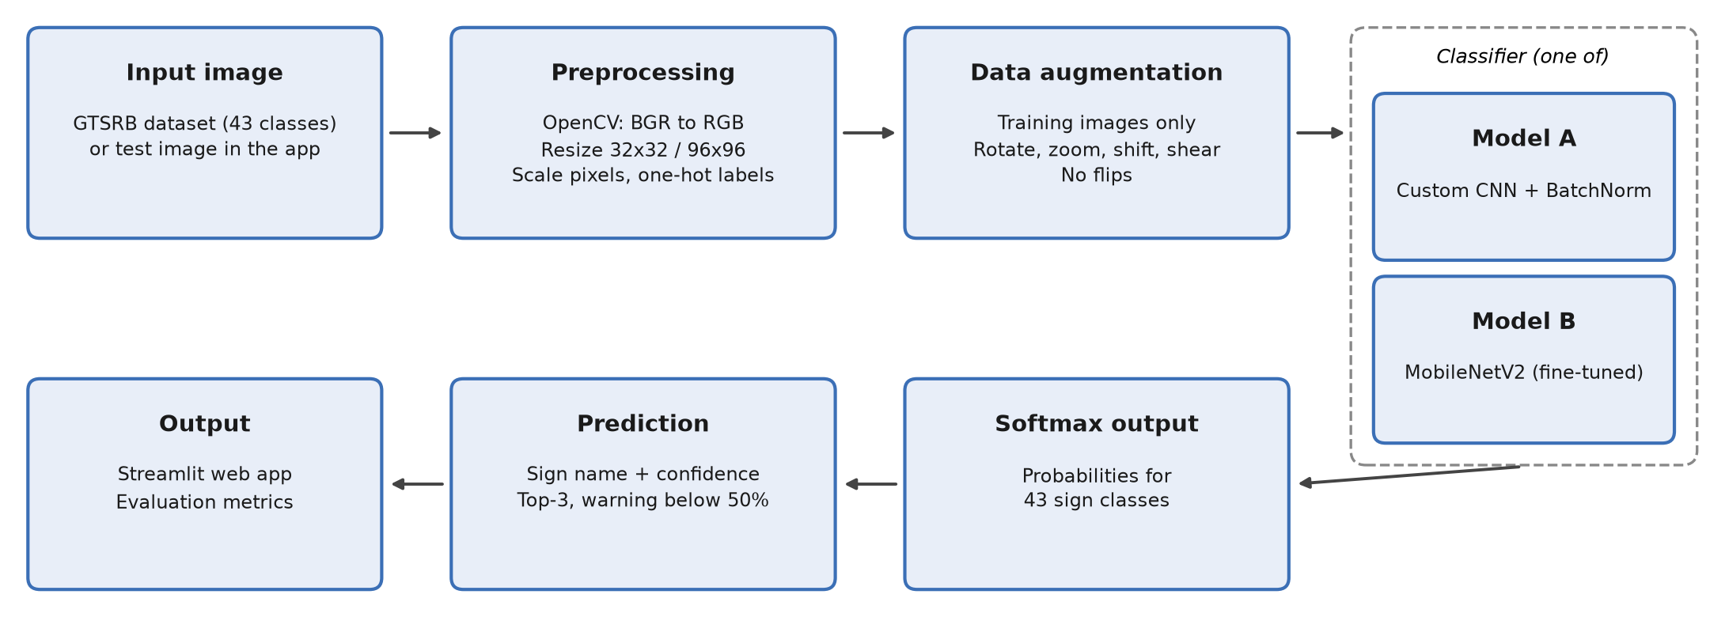
Fig. 3.1: Block diagram of SignSense
Working: An input image (from the dataset, or a test image chosen in the app) is read with OpenCV, converted from BGR to RGB and resized to 32x32 pixels for the custom CNN or 96x96 pixels for MobileNetV2. Pixel values are scaled (divided by 255 for the CNN; scaled to -1..1 for MobileNetV2) and labels are one-hot encoded.
During training only, images are augmented with random rotation (10 degrees), zoom (15%), shift (10%) and shear. Images are never flipped, because flipping changes the meaning of a sign: “Turn left ahead” would become “Turn right ahead” (Fig. 3.2).
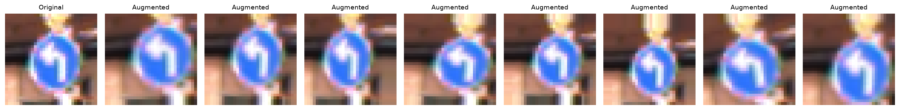
Fig. 3.2: A “Turn left ahead” sign and eight augmented versions (no flips)
The image is then passed to the classifier. Model A is our custom CNN: two blocks of two 3x3 convolutions (32 and 64 filters) with batch normalization, max pooling and dropout (0.25), followed by Flatten, Dense(256), Dropout(0.5) and a 43-way softmax layer (487,243 parameters). Model B is MobileNetV2 pre-trained on ImageNet with a new head (GlobalAveragePooling, Dropout(0.3), Dense(43)); it is first trained with the base frozen and then fine-tuned by unfreezing the top 60 layers (2,313,067 parameters).
The softmax layer outputs a probability for each of the 43 classes. The class with the highest probability is the prediction and its probability is the confidence. The web app shows the sign name, the confidence, the top-3 predictions and a warning when the confidence is below 50%.

3.2 Module Description
The code is organised as a small Python package. Each module has one clear job:
Table 3.1: Project modules
Module | Description
config.py | All paths and hyperparameters (image size, batch size, epochs, learning rates).
data_loader.py | Loads images with OpenCV (BGR to RGB, resize) and labels; caches them as .npz.
preprocess.py | Normalisation, one-hot labels, stratified 80/20 split, augmentation, tf.data pipeline.
models.py | build_custom_cnn() for Model A and build_mobilenet() for Model B.
train.py | Trains a model with EarlyStopping, ModelCheckpoint and ReduceLROnPlateau; saves history.
evaluate.py | Test accuracy, training curves, confusion matrix, per-class report, wrong predictions.
compare.py | Comparison table and chart of all trained models.
predict.py | predict_image(): predicts the sign in one image with the training preprocessing.
app/app.py | Streamlit web app: random test image, model choice, prediction, confidence, top-3 chart.

4. Implementation Result and Analysis
The project was implemented in Python with TensorFlow / Keras, OpenCV, NumPy, pandas, scikit-learn, Matplotlib, Seaborn and Streamlit. The custom CNN was trained on a laptop CPU (Python 3.11, TensorFlow 2.16) and MobileNetV2 on a Google Colab T4 GPU.

4.1 Implementation Screenshots
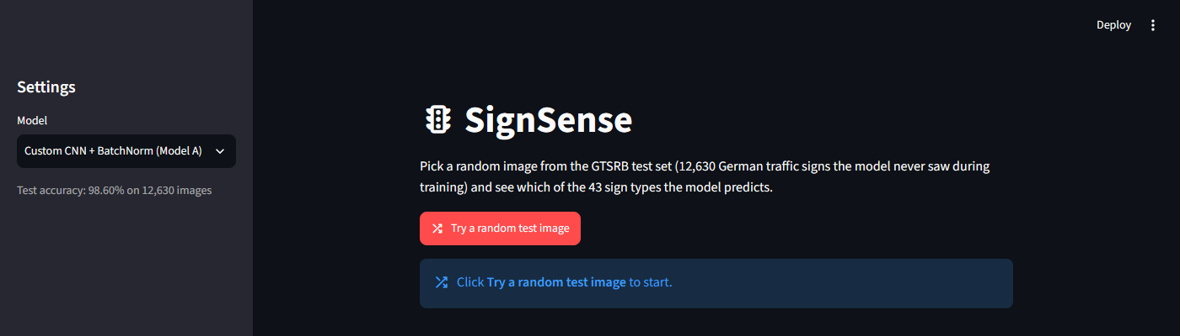
Fig. 4.1: SignSense web app: home page
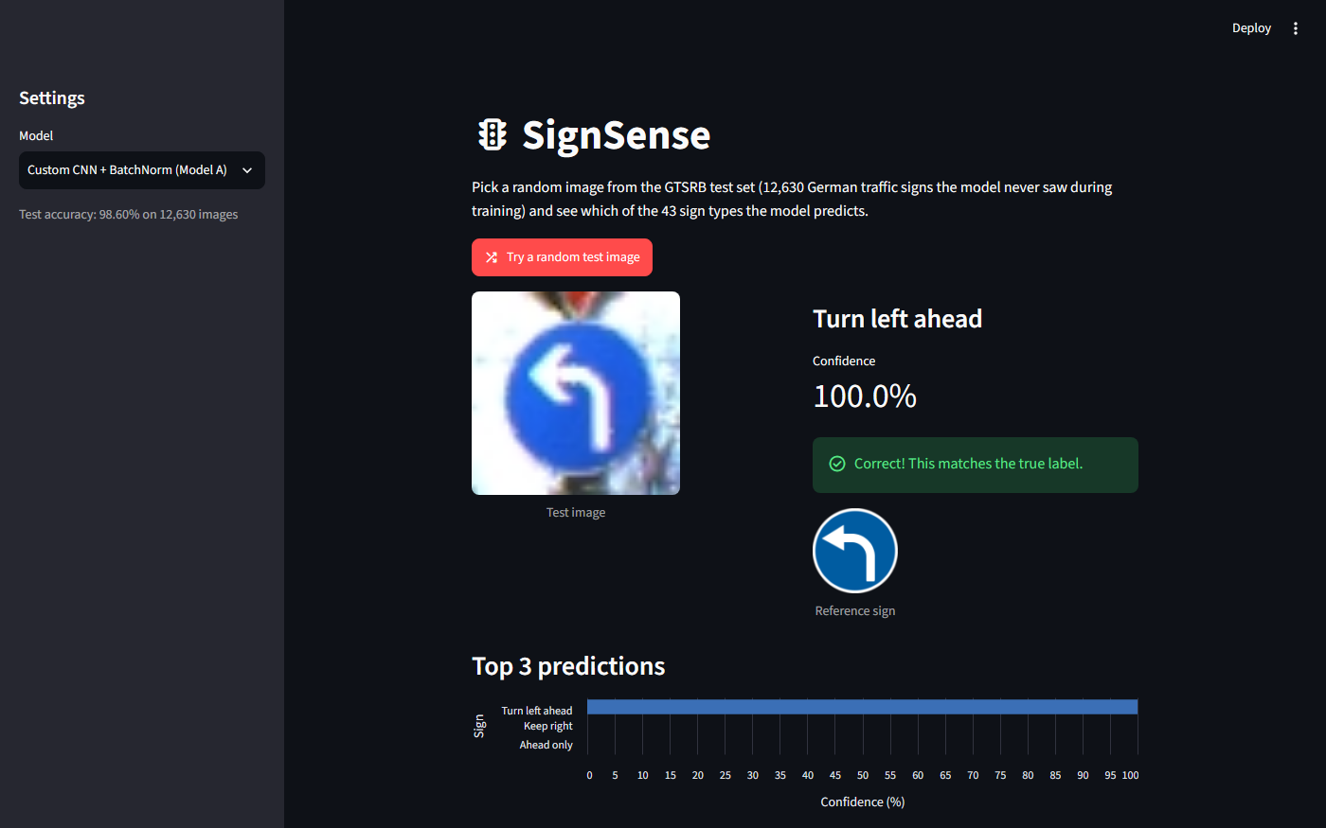
Fig. 4.2: SignSense web app: prediction with confidence and top-3 chart

4.2 Training and Test Results
Table 4.1: Training settings
Setting | Model A: Custom CNN | Model B: MobileNetV2
Input size | 32 x 32 x 3 | 96 x 96 x 3
Optimizer, learning rate | Adam, 0.001 | Adam, 0.001 then 0.0001
Epochs, batch size | up to 20, 64 | 10 + 15 (fine-tuning), 64
Training time | 12.5 min (CPU) | 8.9 min (T4 GPU)

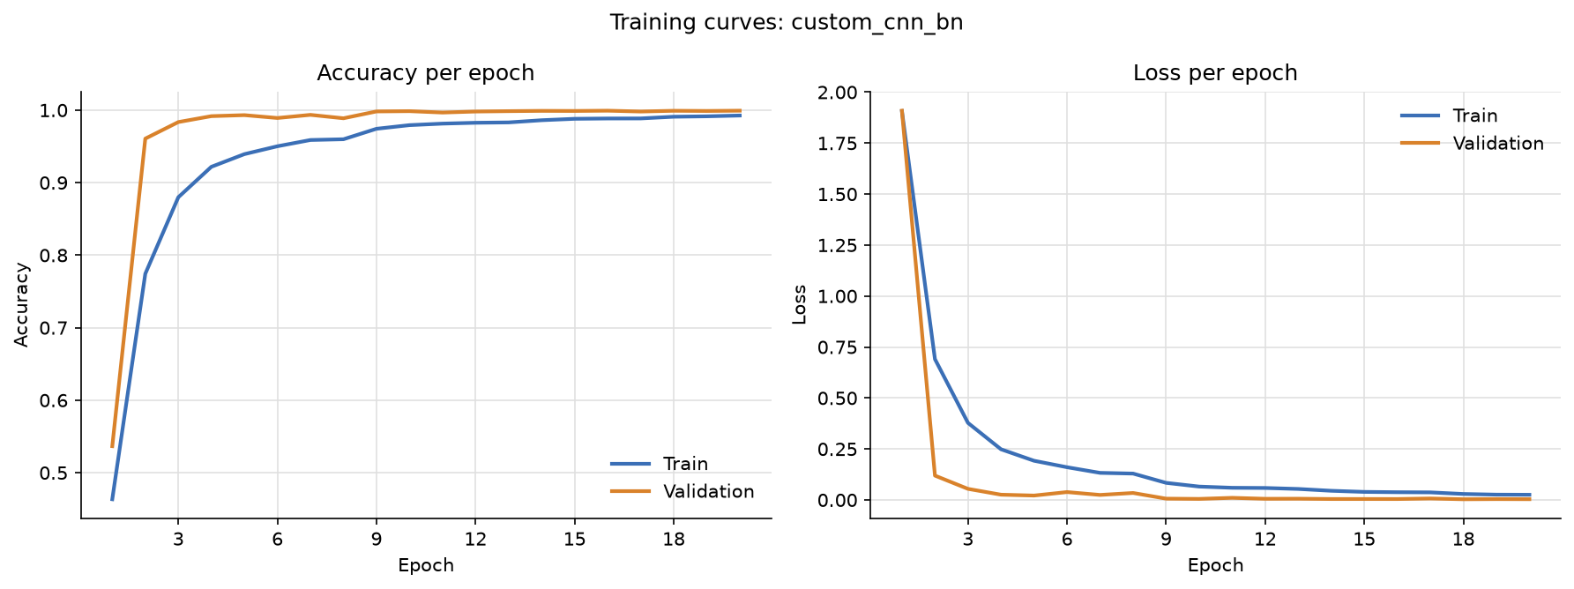
Fig. 4.3: Training and validation accuracy and loss of Model A
Model A reached 98.60% accuracy on the official test set (177 wrong out of 12,630), above the 95% target. Validation accuracy (99.92%) is higher than test accuracy because the training data contains “tracks” of about 30 near-identical photos of each physical sign, so a random split puts similar images in both training and validation. Training accuracy stays slightly below validation accuracy because training images are augmented and dropout is active only during training. Adding batch normalization to the baseline CNN raised test accuracy from 98.05% to 98.60% for only 768 extra parameters.

4.3 Comparison of Model A and Model B
Table 4.2: Comparison on the official test set (12,630 images)
Model | Parameters | Test accuracy | Macro-F1 | File size
Custom CNN (baseline) | 486,475 | 98.05% | 0.963 | 5.9 MB
Custom CNN + BatchNorm (Model A) | 487,243 | 98.60% | 0.973 | 5.9 MB
MobileNetV2, light fine-tuning | 2,313,067 | 66.75% | - | -
MobileNetV2, fine-tuned (Model B) | 2,313,067 | 88.30% | 0.842 | 26.0 MB

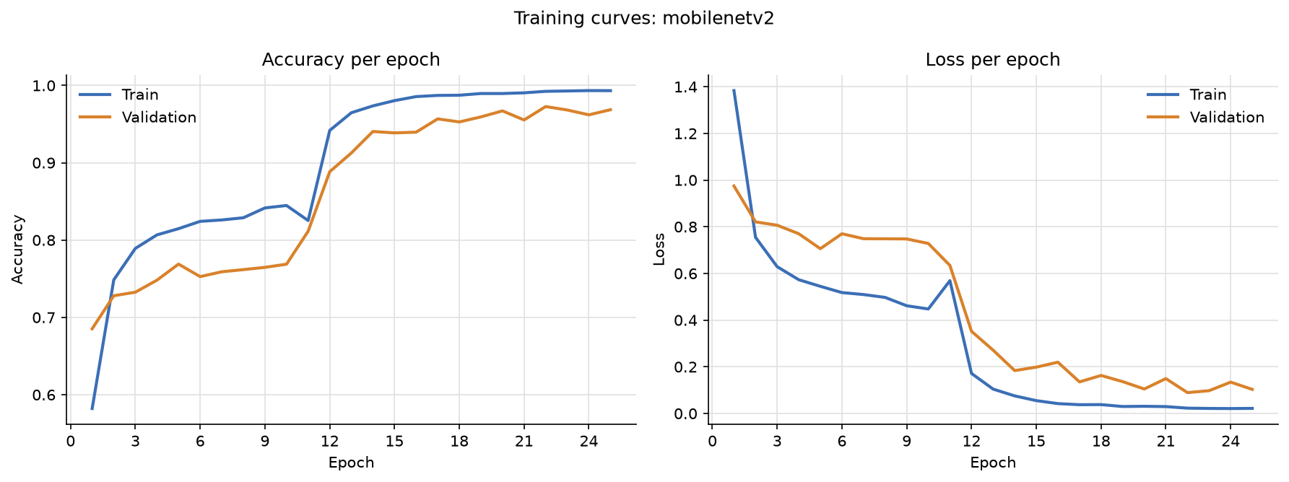
Fig. 4.4: MobileNetV2 training: fine-tuning starts at epoch 11
The small custom CNN is more accurate than MobileNetV2 while being about 5 times smaller. MobileNetV2 was pre-trained on large, detailed ImageNet photos, while GTSRB images are tiny and blurry. Its GlobalAveragePooling layer also discards the position of features, so left and right signs are confused (“Go straight or right” was predicted as “Go straight or left” 33 times). Fine-tuning was essential: with the base frozen, validation accuracy stalled at about 77%, and it jumped to 97% once the top 60 layers were unfrozen (Fig. 4.4).

4.4 Error Analysis
Table 4.3: Five classes with the lowest F1-score (Model A)
Class | F1 | Recall | Main confusion
27 Pedestrians | 0.66 | 50% | predicted as Children crossing (25 of 60)
22 Bumpy road | 0.86 | 75% | predicted as Road work (28 of 120)
40 Roundabout mandatory | 0.89 | 99% | Priority road predicted as Roundabout (19)
28 Children crossing | 0.92 | 100% | receives the Pedestrians errors (25)
21 Double curve | 0.93 | 100% | General caution predicted as Double curve (13)

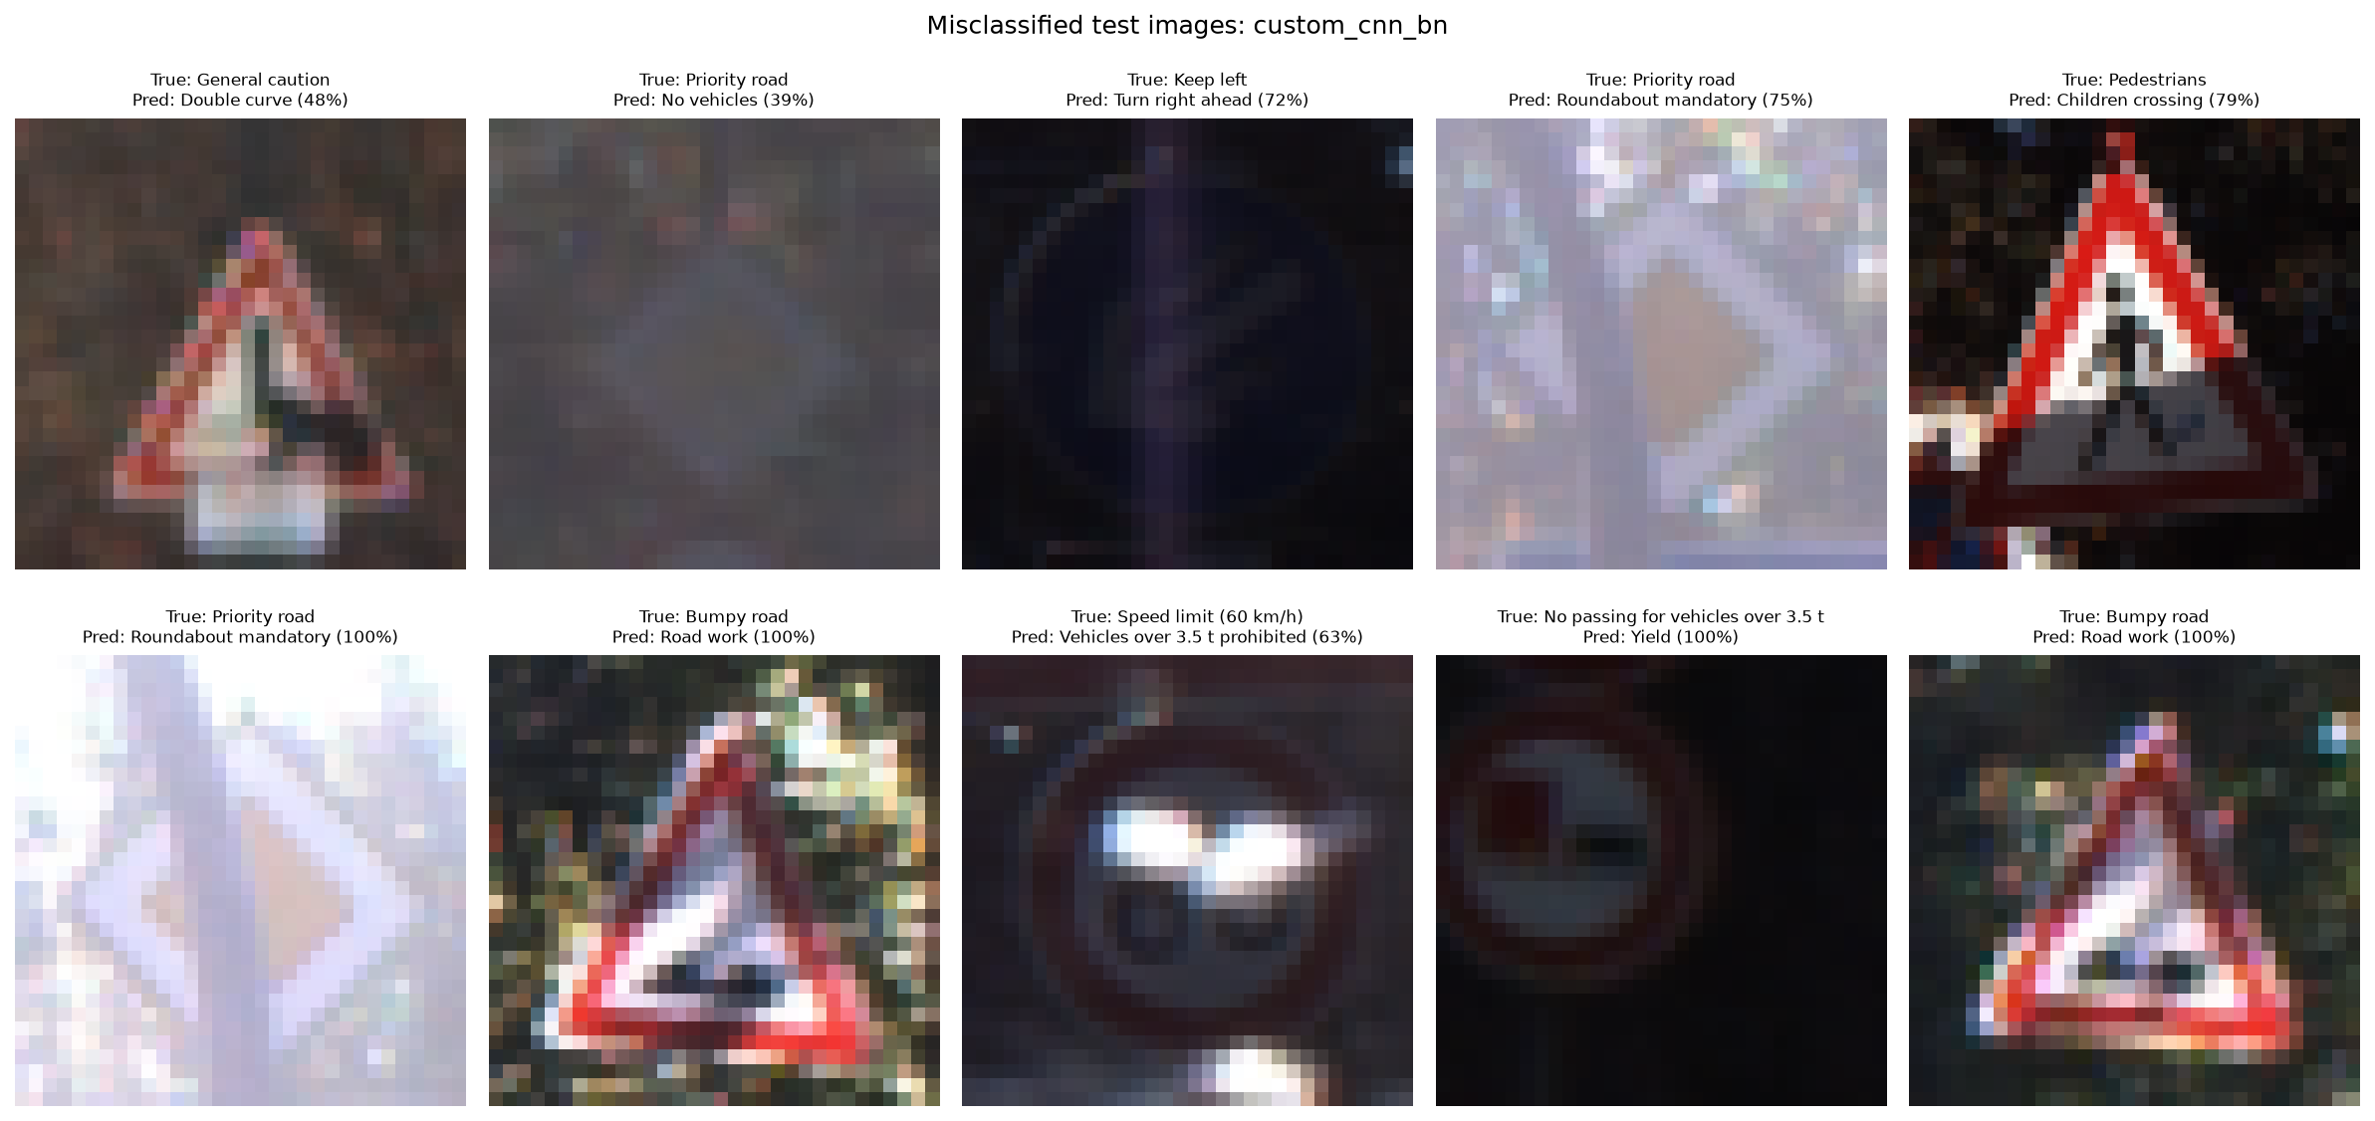
Fig. 4.5: Examples of misclassified test images (Model A)
Most errors are between triangular warning signs with the same red border, whose only difference is a small black symbol that is just a few pixels wide at 32x32. Several of these classes are rare (Pedestrians has only 240 training images), and many wrong images are very dark, blurred or overexposed.

5. Code
The most important parts of the code are shown below. The full code is in the project repository and in the Colab notebook.
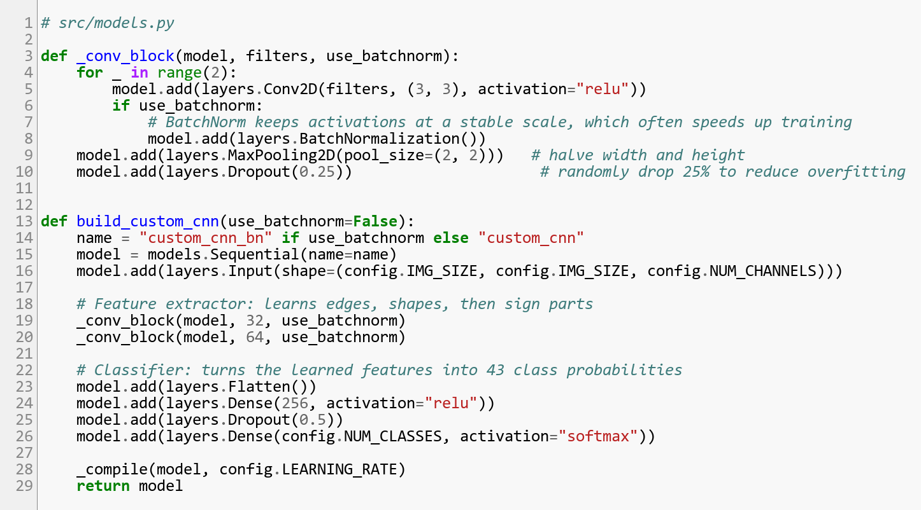
Fig. 5.1: Model A, custom CNN (models.py)
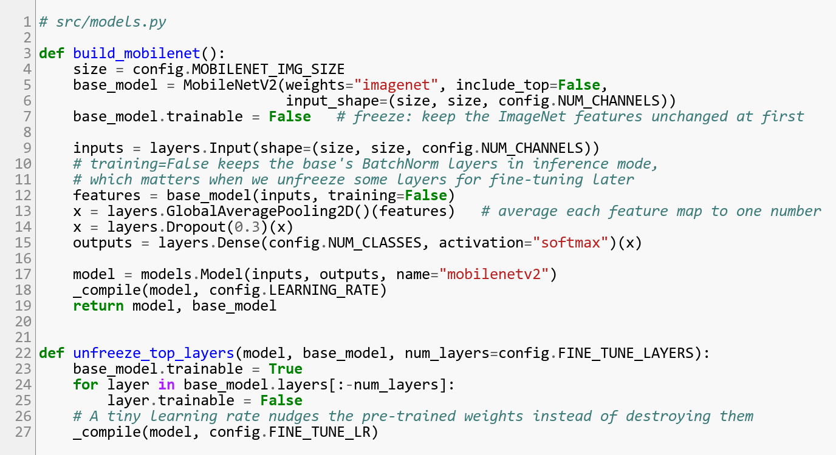
Fig. 5.2: Model B, MobileNetV2 transfer learning (models.py)
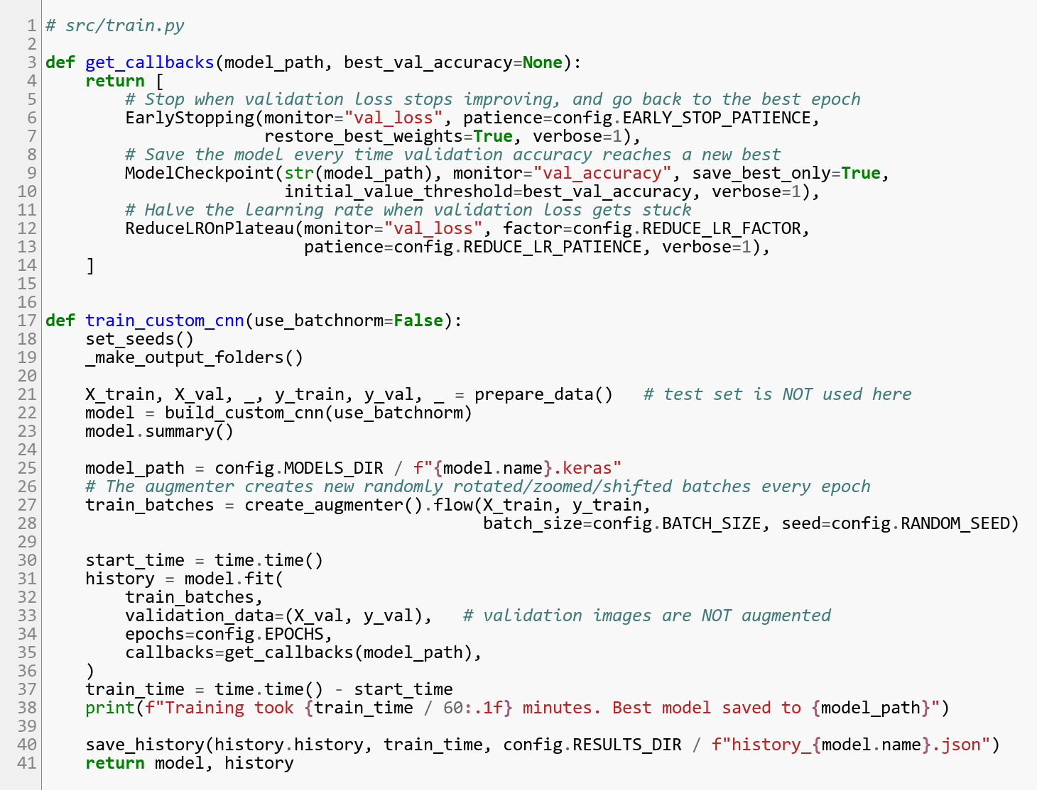
Fig. 5.3: Training with callbacks (train.py)
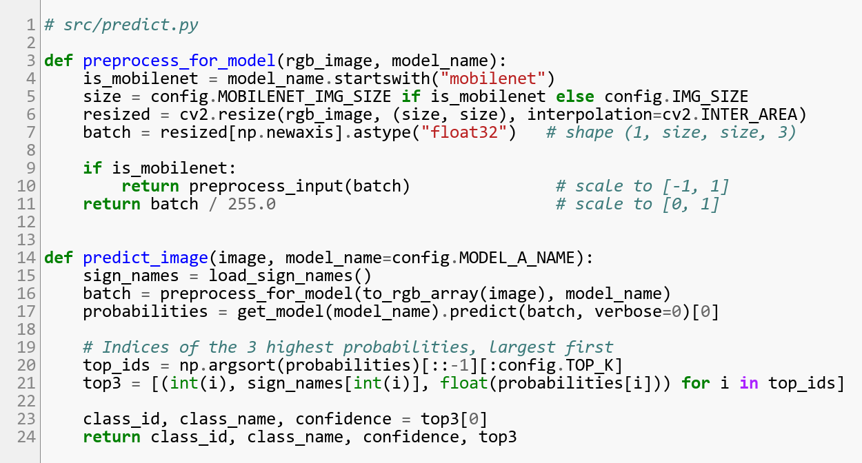
Fig. 5.4: Predicting a single image (predict.py)

6. Conclusion
We built SignSense, a traffic sign recognition system for the 43 GTSRB classes. A compact custom CNN with data augmentation (without flips), dropout and batch normalization reached 98.60% test accuracy with fewer than 0.5 million parameters, above the 95% target. MobileNetV2 transfer learning reached 88.30% after fine-tuning, showing that pre-trained ImageNet features do not transfer well to tiny, low-resolution sign images and that fine-tuning is essential. The remaining errors come mainly from similar triangular warning signs, rare classes and poor image quality. A Streamlit web app demonstrates the model on unseen test images.

6.1 Limitations and Future Scope
- The models only know the 43 GTSRB classes: a sign from outside these classes is still forced into the closest known class, so the demo uses test images only.
- The models classify already cropped signs; real-time detection in full camera frames could be added with an object detector such as YOLO.
- Video input from a dashcam, combining predictions over several frames.
- Training on more datasets, such as Indian traffic signs, to handle other countries.
- Deployment on mobile and edge devices with TensorFlow Lite; our model is only about 6 MB.
- Higher accuracy through cropping to the sign's bounding box, class weights for rare classes and higher input resolution.

References
[1] J. Stallkamp, M. Schlipsing, J. Salmen and C. Igel, “Man vs. computer: Benchmarking machine learning algorithms for traffic sign recognition,” Neural Networks, vol. 32, pp. 323-332, 2012.
[2] M. Sandler, A. Howard, M. Zhu, A. Zhmoginov and L.-C. Chen, “MobileNetV2: Inverted residuals and linear bottlenecks,” in Proc. IEEE/CVF Conference on Computer Vision and Pattern Recognition (CVPR), 2018, pp. 4510-4520.
[3] S. Ioffe and C. Szegedy, “Batch normalization: Accelerating deep network training by reducing internal covariate shift,” in Proc. International Conference on Machine Learning (ICML), 2015, pp. 448-456.
[4] N. Srivastava, G. Hinton, A. Krizhevsky, I. Sutskever and R. Salakhutdinov, “Dropout: A simple way to prevent neural networks from overfitting,” Journal of Machine Learning Research, vol. 15, pp. 1929-1958, 2014.
[5] D. P. Kingma and J. Ba, “Adam: A method for stochastic optimization,” in Proc. International Conference on Learning Representations (ICLR), 2015.
[6] Kaggle, ‘GTSRB - German Traffic Sign Recognition Benchmark’. [Online]. Available: https://www.kaggle.com/datasets/meowmeowmeowmeowmeow/gtsrb-german-traffic-sign. [Accessed: 19- Oct- 2026].

